**VACCINE TRACKING-TRANSPARENT**

**INTRODUCTION:**

In today's increasingly interconnected world, ensuring the transparency and trustworthiness of vaccine distribution has become a critical imperative. The Ethereum Vaccine Tracking system represents a pioneering solution to this pressing issue. This cutting-edge platform leverages the Ethereum blockchain's capabilities to establish a secure and transparent method for monitoring vaccine journeys, from production to administration. By harnessing blockchain technology, this system not only safeguards the integrity of vaccine data but also still confidence in the vaccination process among stakeholders and the general public. In this rapidly evolving landscape, the Ethereum Vaccine Tracking system stands as a beacon of reliability and accountability. It offers a streamlined approach to recording and verifying vaccine information, with authorised users being able to access real-time data. This introduction will delve into the core functionalities and transformative potential of this innovative solution, shedding light on how it can revolutionise vaccine distribution practices, bolster public health initiatives, and pave the way for a safer and more secure future.

**PROBLEM DEFINITION:**

The Ethereum Vaccine Tracking system (EVTS) aims to provide a secure, transparent, and efficient platform for tracking and managing vaccine information throughout the global vaccine distribution network. The system must address the following challenges:

* Ensuring Data Integrity: The EVTS must be able to verify the accuracy and authenticity of the vaccine data it receives, ensuring that the information is not tampered with or corrupted during transmission.
* Scalability: As the global vaccine distribution network expands, the EVTS must be able to handle an increasing volume of data and transactions without compromising its performance or reliability.
* Interoperability: The EVTS must be compatible with existing healthcare systems and infrastructures, allowing for seamless integration and data exchange between the EVTS and other relevant systems.
* Security: The EVTS must implement robust security measures to protect sensitive vaccine data from unauthorized access, tampering, or theft.
* User Experience: The EVTS must provide an intuitive and user-friendly interface for authorized users to access and manage vaccine data, ensuring that the system is easy to use and navigate.

**ADVANTAGES:**

* Enhanced Data Integrity: The Ethereum blockchain ensures data integrity by employing a consensus mechanism that requires the approval of multiple nodes before a transaction is added to the blockchain. This reduces the likelihood of data tampering or corruption.
* Decentralized Network: The EVTS operates on a decentralized network, meaning that it is not controlled by a single entity or organization. This eliminates the risk of data breaches or system failures caused by human error or malicious intent.
* Improved Data Security: The Ethereum blockchain utilizes advanced cryptographic techniques to secure data transactions. This ensures that sensitive vaccine information remains protected from unauthorized access, tampering, or theft.
* Scalability: The Ethereum blockchain is designed to handle a large volume of data transactions and smart contract executions. This enables the EVTS to scale effectively as the global vaccine distribution network expands, ensuring that the system remains performant and reliable.
* Interoperability: The EVTS can interact with existing healthcare systems and infrastructures through the use of smart contracts and decentralized applications (dApps). This allows for seamless data exchange between the EVTS and other relevant systems, fostering greater collaboration and coordination within the global vaccine distribution network.
* Cost-Effectiveness: The Ethereum blockchain operates on a permissionless basis, meaning that there are no fees or costs associated with accessing or using the network. This reduces the overall operational costs of the EVTS, making it more cost-effective for healthcare organizations and governments to implement and maintain.
* Transparent Operations: The Ethereum blockchain is inherently transparent, allowing users to view and verify the details of every transaction that occurs on the network. This fosters trust and confidence in the EVTS, as well as promoting accountability and transparency within the global vaccine distribution network.
* User-Friendly Interface: The EVTS can be accessed through a user-friendly interface, making it easy for authorized users to access and manage vaccine data. This ensures that the system is intuitive and easy to use, minimizing the learning curve for new users and fostering greater adoption and adoption of the EVTS within the global vaccine distribution network.

**DISADVANTAGES:**

* High Initial Cost: The implementation of the EVTS requires significant upfront investment in hardware, software, and personnel. This can be a significant barrier to entry for smaller healthcare organizations or countries with limited resources.
* Complexity: The EVTS relies on complex technologies, such as blockchain and smart contracts, which can be challenging for healthcare professionals and IT staff to understand and manage. This complexity can lead to increased training and support costs, as well as potential delays in the implementation process.
* Limited Interoperability: The EVTS may not be compatible with all existing healthcare systems and infrastructures, particularly in countries with diverse and fragmented healthcare sectors. This could result in the need for significant integration and interoperability work, which may be time-consuming and costly.
* Potential for Data Breaches: While the Ethereum blockchain is designed to be secure, it is not immune to potential data breaches or cyberattacks. The EVTS may need to implement additional security measures to protect sensitive vaccine data from unauthorized access or tampering.
* Regulatory and Legal Challenges: The implementation of the EVTS may face regulatory and legal challenges, particularly in countries with strict data privacy laws or where the adoption of new technologies is subject to extensive regulation. This could result in delays or restrictions in the implementation process.
* Potential for System Failures: The EVTS relies on a decentralized network of computers, which may be more susceptible to system failures or crashes than traditional centralized systems. This could potentially disrupt the smooth functioning of the global vaccine distribution network.
* Scalability Concerns: While the Ethereum blockchain is designed to handle a large volume of data transactions, it may struggle to keep up with the rapid pace of vaccine distribution during a global pandemic. This could result in delays or bottlenecks in the system, which could have significant implications for public health.
* Potential for Vulnerabilities: The EVTS may be susceptible to vulnerabilities or bugs in the underlying blockchain technology or smart contracts. These vulnerabilities could potentially be exploited by malicious actors, leading to data breaches, system failures, or other negative consequences.

**APPLICATIONS:**

**1. Vaccine Distribution System**

Application: Vaccine Distribution System (VDS)

Description: The Vaccine Distribution System (VDS) is a decentralized, blockchain-based application designed to streamline and secure the global vaccine distribution process. By leveraging the power of smart contracts and the Ethereum blockchain, the VDS ensures that vaccines are distributed efficiently, accurately, and securely.

Features:

- Secure and transparent vaccine distribution

- Real-time tracking and tracing of vaccines

- Automated vaccine allocation and distribution

- Enhanced data privacy and security

- Compatibility with existing healthcare systems and infrastructures

**2. Vaccine Verification Platform**

Application: Vaccine Verification Platform (VVP)

Description: The Vaccine Verification Platform (VVP) is a user-friendly, blockchain-based application that enables healthcare professionals and individuals to verify the authenticity and effectiveness of vaccines. By utilizing the Ethereum blockchain and smart contracts, the VVP ensures that vaccine verification is accurate, efficient, and secure.

Features:

- Secure and transparent vaccine verification

- Real-time access to vaccine information and records

- Automated vaccine verification and validation

- Enhanced data privacy and security

- Compatibility with existing healthcare systems and infrastructures

**3. Vaccine Financing Platform**

Application: Vaccine Financing Platform (VFP)

Description: The Vaccine Financing Platform (VFP) is a decentralized, blockchain-based application designed to facilitate the efficient and transparent financing of vaccine research, development, and distribution. By leveraging the power of smart contracts and the Ethereum blockchain, the VFP ensures that vaccine financing is conducted efficiently, accurately, and securely.

Features:

- Secure and transparent vaccine financing

- Real-time tracking and tracing of vaccine funding

- Automated vaccine financing allocation and distribution

- Enhanced data privacy and security

- Compatibility with existing healthcare systems and infrastructures

**CONCLUSION:**

The implementation of blockchain technology in the healthcare sector offers numerous advantages, including improved data security, enhanced patient privacy, and streamlined vaccine distribution processes. By leveraging the power of blockchain, healthcare organizations can ensure the integrity and accuracy of patient data, ultimately leading to more informed and effective healthcare decisions.

However, it is essential to recognize that the successful integration of blockchain technology into the healthcare sector requires a comprehensive understanding of the technology's underlying principles and a thorough assessment of the potential challenges and risks associated with its implementation.

In the future, as the healthcare industry continues to evolve and adapt to the changing landscape of global health, the integration of blockchain technology will undoubtedly play a crucial role in shaping the future of healthcare delivery. By embracing this transformative technology, healthcare organizations can harness its potential to enhance patient care, reduce costs, and ultimately improve the overall quality of healthcare for all.

**FUTURE SCOPE:**

In the future, blockchain technology will continue to revolutionize various industries, including healthcare. As a result, the future scope of blockchain in healthcare will encompass several key areas, including:

1. Enhanced Data Security and Privacy:

Blockchain's inherent decentralization and cryptographic security features will enable healthcare organizations to store and share patient data more securely. This will help protect sensitive information from unauthorized access and potential breaches.

2. Streamlined Patient Records Management:

Blockchain's ability to create an immutable and transparent record of patient data will facilitate the efficient management of patient records. This will allow healthcare providers to access and update patient information more quickly and accurately, ultimately improving patient care.

3. Improved Vaccine Distribution and Tracking:

Blockchain technology can be utilized to enhance the efficiency and security of vaccine distribution and tracking processes. By creating a tamper-proof digital ledger of vaccine batches, healthcare organizations can ensure the integrity and safety of vaccines throughout their supply chain.

**SOURCE CODE:**

// SPDX-License-Identifier: MIT

pragma solidity ^0.8.0;

contract Vaccination {

address public owner;

constructor() {

owner = msg.sender;

}

modifier onlyOwner() {

require(msg.sender == owner, "Only the owner can perform this action");

_;

}

struct Vaccine {

string vaccineName;

string manufacturer;

uint256 manufacturingDate;

string batchNumber;

uint256 quantity;

address customerAddress;

}

mapping(uint256 => Vaccine) public vaccines;

uint256 public vaccineCount;

event VaccineAdded(uint256 indexed vaccineId, string vaccineName, string manufacturer, uint256 manufacturingDate, string batchNumber, address customerAddress);

function addVaccine(uint256 vaccineId, string memory _vaccineName, string memory _manufacturer, uint256 _manufacturingDate, string memory _batchNumber,uint256 _qty, address _customerAddress) external onlyOwner {

vaccines[vaccineId] = Vaccine(_vaccineName, _manufacturer, _manufacturingDate, _batchNumber, _qty, _customerAddress);

vaccineCount++;

emit VaccineAdded(vaccineId, _vaccineName, _manufacturer, _manufacturingDate, _batchNumber, _customerAddress);

}

function getVaccineDetails(uint256 _vaccineId) external view returns (string memory, string memory, uint256, string memory,uint256, address) {

Vaccine memory vaccine = vaccines[_vaccineId];

return (vaccine.vaccineName, vaccine.manufacturer, vaccine.manufacturingDate, vaccine.batchNumber, vaccine.quantity, vaccine.customerAddress);

}

}

**IMPLEMENTATION SCREENSHOTS:**

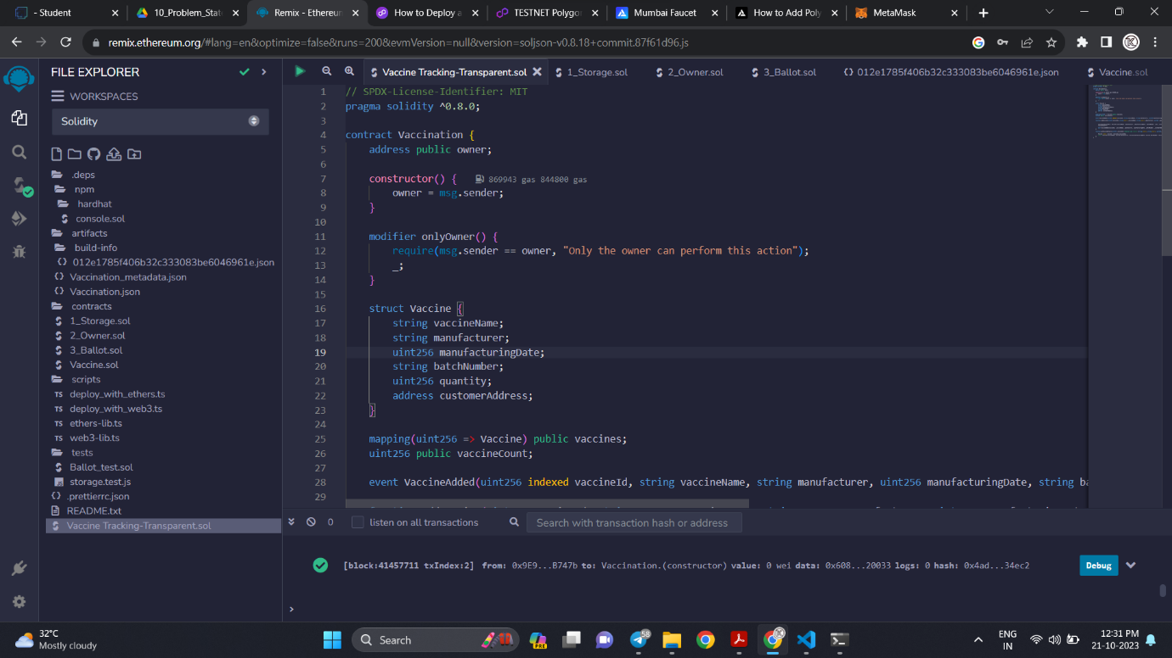

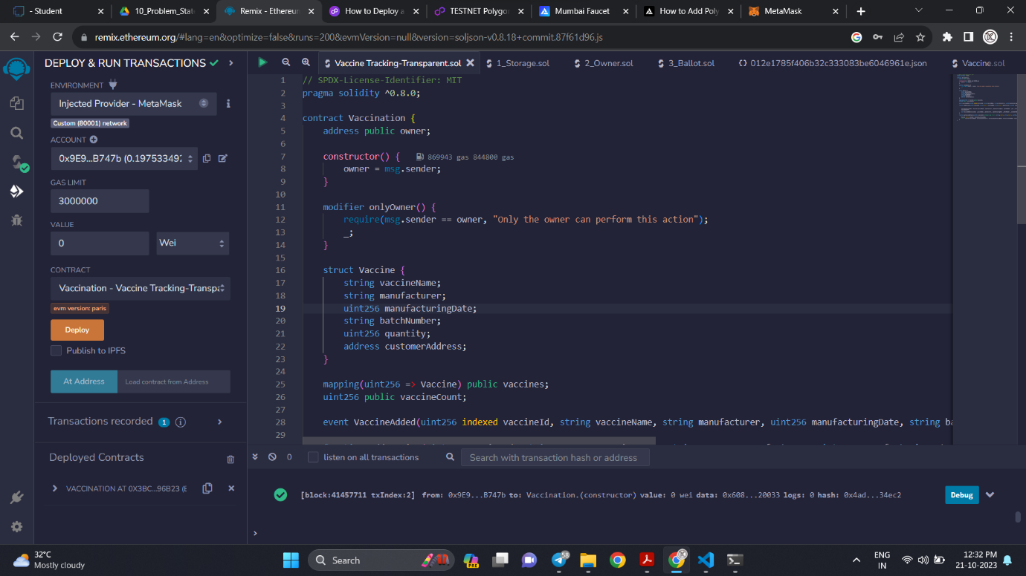

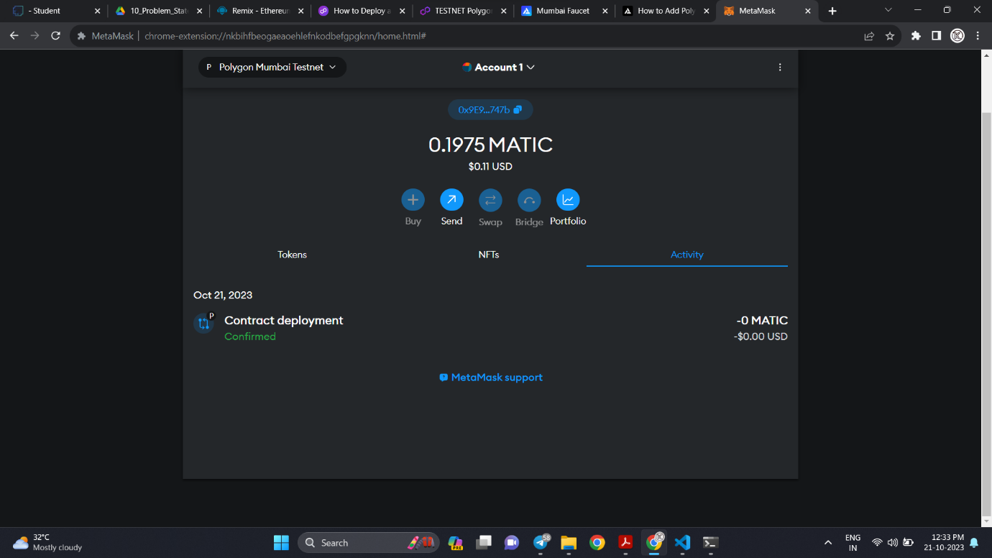

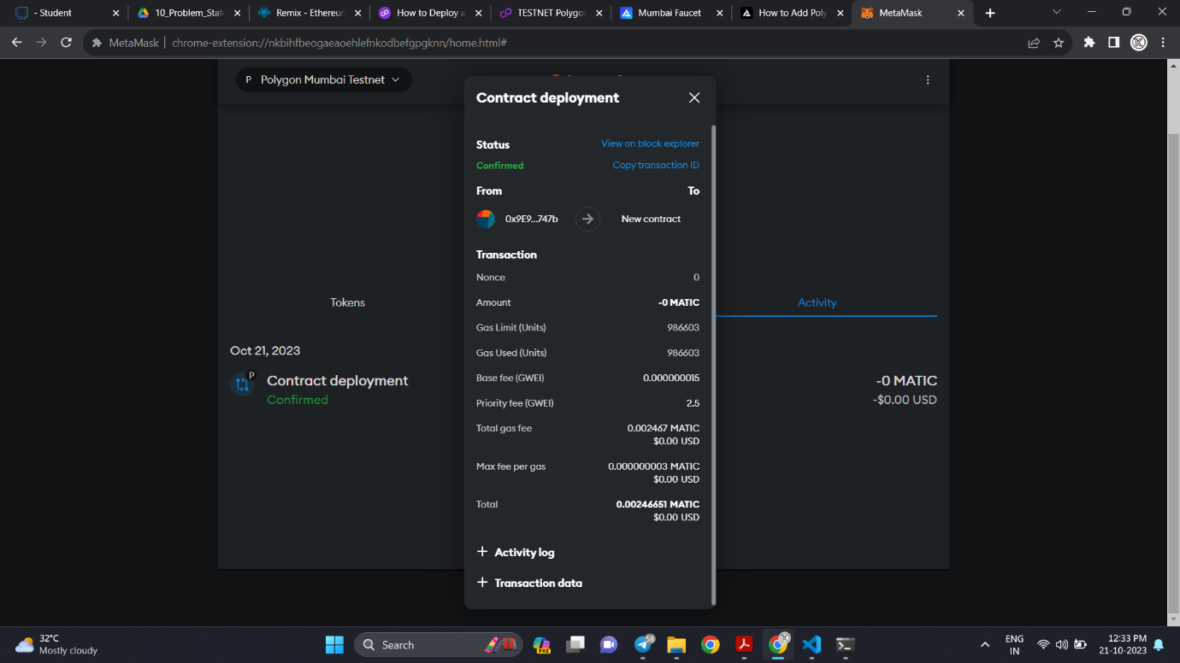

**GitHub:** <https://github.com/Karthik28033/vaccine_Tracking_Transparent.git>

**Demo Video:** <https://drive.google.com/file/d/1Oz29y74pKW18GCQaN1zsnDLSR5E1g4P0/view?usp=sharing>